Scoliotic spine visualization using   
ultrasound-accessible anatomic landmarks

Ben Church1, Tamas Ungi1, Andras Lasso1, Christopher Schlenger2,   
Dan Borschneck3, Parvin Mousavi4, Gabor Fichtinger1

1. Laboratory for Percutaneous Surgery, School of Computing, Queen’s University, Kingston, ON, Canada
2. Premier Chiropractic, Stockton, CA, USA
3. Department of Surgery, Queen’s University, Kingston, ON, Canada
4. Medical Informatics Laboratory, School of Computing, Queen’s University, Kingston, ON, Canada

**ABSTRACT**

**PURPOSE:** Ultrasound imaging is an attractive alternative to X-ray for scoliosis diagnosis and monitoring due to its safety and inexpensiveness. The transverse processes provide landmarks which are accessible by means of ultrasound, and are sufficient for quantifying scoliosis, but, own their own, do not provide an intuitively comprehensible visualization of the spine. **METHODS:** We created 3D surface models of individual patients’ scoliotic spines using the transverse processes locations, and an average shaped, healthy spine model registered to them. The method consists of manually locating the transverse processes, and programmatically adding anchor points to the sets of transverse process points to ensure accurate registration of the average spine model to them. **RESULTS:** The registration resulted in 3D transformation fields, interpolated as a thin-plate spline between points, which were then applied over the surface of the average spine model, yielding 3D surface models of the patients’ spines. Hausdorff distances, Dice similarity coefficients, and model-to-model distance maps were computed to evaluate the quality of the registration based models compared to ground truth, CT-derived patient spine models. **CONCLUSIONS:** This method is shown to be capable of producing models which depict the 3D deformation of the patients’ spines when compared to ground truth CT scans.

**Keywords:** Spine**,** scoliosis, modelling, ultrasound, landmark, visualization

# BACKGROUND AND PURPOSE

Scoliosis is a pathological curvature of the spine which typically manifests and develops during adolescence and growth. If left untreated, scoliosis can progress to the point that back pain or respiratory problems develop. Management of the disease requires that the progression of its resulting deformation be monitored. Scoliosis is quantified in terms of the Cobb angle, the maximum angle between the endplates of any two vertebrae. Continued observation and measurement is typically indicated for patients exhibiting a Cobb angle of less than 20°. Bracing can be used to prevent further progression of the disease for a Cobb angle between 20° and 40°. Any curvature in excess of 40° is often treated with surgical vertebral fusing [Frerich 2012].

Accurate knowledge of spinal deformation is therefore crucial in ensuring that patients receive the appropriate treatment. X-ray is considered the gold-standard for scoliosis quantification and visualization. The risks of repetitive exposure to ionizing radiation during adolescence have motivated investigation into the use of ultrasound as an alternative [Berton 2016]. Ultrasound imaging, in addition to conveying 3D deformation information when tracking is used, is less expensive than X-ray, partly because its inherent safety has meant fewer regulations are needed for its use. Should ultrasound technology for scoliosis quantification become sufficiently mature, its safety and inexpensiveness make it an attractive tool not only for scoliosis progression monitoring, but also for screening in schools, and for chiropractic treatment monitoring.

Despite experimental results with tracked ultrasound as an imaging modality for scoliosis monitoring, bone surfaces can be difficult to locate in ultrasound. Ultrasound can only visualize parts of the posterior surface of the spine, which, despite being sufficient to determine the Cobb angle, does not provide a practitioner with a comprehensible visualization of the patient’s spine. To produce spine models from the ultrasound images, previous CT images of the same patient, or standard spine shape models, have been spatially registered to anatomic landmarks obtained by ultrasound. We have previously shown that a few anatomic landmarks visible in ultrasound images are sufficient for accurate registration of CT-derived models of vertebrae [Ungi 2013], but this requires significant time and an experienced sonographer, and most patients do not have a CT scan of their whole spine.

An accurately registered model can therefore be used to approximate a patient’s anatomy for a number of purposes. Gill et al. [Gill 2012] registered lumbar spine surfaces extracted from ultrasound to existing CT scans of the corresponding cadavers and patient-based phantoms. They used an iterative closest point (ICP), rigid registration to achieve initial alignment between the CT model and landmark point set, and then registered each vertebra as a rigid body to account for inter-imaging changes in posture or anatomy. In the work presented here, we investigated if an average healthy spine model could be registered to ultrasound-accessible landmarks of scoliotic spines in the absence of patient-specific CT. Such a registration method would allow visualization of the full spine based on a few patient-specific landmarks.

# NEW OR BREAKTHROUGH WORK

We have developed a method to create 3D models of patients’ scoliotic spines based on the locations of the transverse processes, and a standard-anatomic, average, healthy spine model. We have shown that this registration method produces a qualitative visual representation of the spine that is sufficiently accurate for a number of clinical applications.

# METHODS

Landmark based registration requires two sets of points, one to be registered to the other. The first set of points consisted of the transverse processes from an average, healthy spine surface model. The second point set was the transverse processes from the CT-derived model the of patient’s scoliotic spine. The landmark point sets, such as those depicted in Figure 1, effectively consist of two nearly parallel curves, one along the left transverse processes, and the other along the right. Despite the visibility of these points in ultrasound, the information contained therein is nearly 1D (plus the spacing between the curves) and therefore cannot reliably encode the 3D deformation we wished to impose on the average spine model. In a healthy spine, the transverse processes of two adjacent vertebrae define a trapezoid as its vertices, while the deformation of a scoliotic spine warps this trapezoid into a general quadrilateral. This is illustrated in Figure 1.

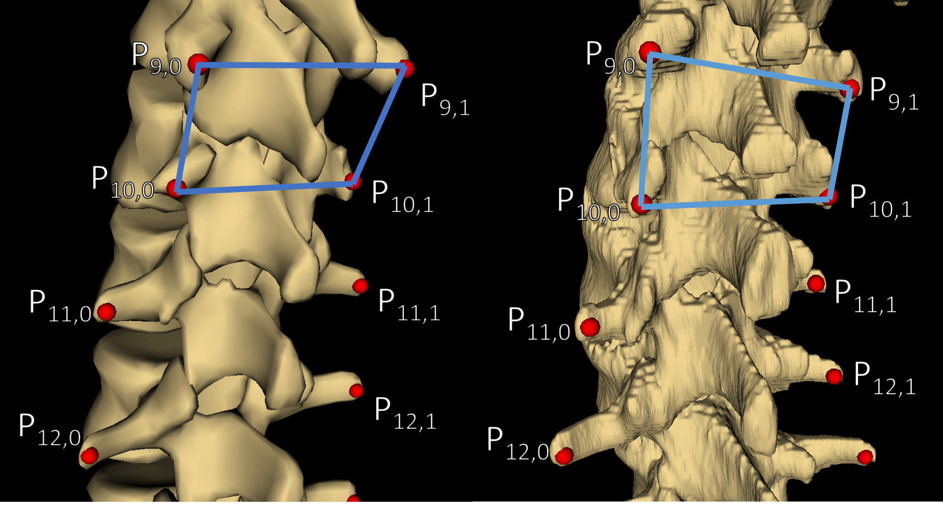

Figure 1: (Left) Model of average spine with transverse processes marked and the trapezoid defined by those of T11 (P9,0 – P9,1) and T12 (P10,0 – P10,1). (Right) Ct-derived model of patient #1’s spine showing the quadrilateral defined by the same vertebrae.

We remedied the difficulty of representing 3D deformation with two 1D curves by adding anchor points to the patient’s and the average model’s point sets, one anchor point for each transverse process point. To convey a maximum of 3D information, the anchor points were added to the existing points at offsets normal to the curvature of the spines, in the anterior direction. This method effectively defined volumes, rather than curves, analogous to extruding the quadrilaterals of Figure 1 normal to their surfaces. By constructing such a volume for each vertebra, the registration algorithm imposed most of its deformation intervertebrally, rather than continuously along the curves. Finally, by scaling the magnitude of the offset distance by the ratio of the length of the patient’s spine to that of the average model, variability in the length scales of the spines was also conveyed to the registration method. To compute consistent directions normal to the curves, vector cross products of right-left, and superior-inferior vectors were computed and used to define the offset direction.

To add the anchor point anterior to point Pi,j, where i denotes the vertebra (the superior-most being at i = 0), and where j denotes whether it is the left or right point (j = 0 for the left, j = 1 for the right), the right-left vector was computed as:

$\overset{⃑}{RL_{i},_{j}}=\overset{⃑}{P_{i},_{j}}-\overset{⃑}{P_{i},_{j+1(mod 2)}}$ (1)

where the arrows denote vector representations of the points’ locations in 3D space.

The superior-inferior vectors were computed as the average of two possible vectors:

$\overset{⃑}{SI_{i},_{j}}=\left[\left(\overset{⃑}{P_{i+1},_{j}}-\overset{⃑}{P_{i},_{j}}\right)+\left(\overset{⃑}{P_{i},_{j}}-\overset{⃑}{P_{i-1},_{j}}\right)\right]÷2$ (2)

At the superior and inferior extremities of the spine models, where only one vertebra existed below or above the one to which an anchor point was currently being added, respectively, only the existing vector was used in equation (2).

Finally, to determine the location of the anchor point, the cross product of the vectors from equations (1) and (2) was computed, normalized by dividing it by its length, scaled by a vertebral scaling factor times the ratio of the length of the patient’s spine to that of the average spine model:

$\overset{⃑}{P_{i},_{j}*}=\overset{⃑}{P_{i},_{j}}+\left[VSF∙\left(L_{P}÷L_{A}\right)\right]∙\left(\overset{⃑}{RL_{i},_{j}}×\overset{⃑}{SI_{i},_{j}}\right)÷\left|\overset{⃑}{RL_{i},_{j}}×\overset{⃑}{SI_{i},_{j}}\right|$ (3)

where the * denotes an anchor point being added, VSF is the vertebral scaling factor used to offset the anchor point at a distance representative of the length scales already existing between landmarks, • denotes scalar multiplication, LP is the length of the patient’s spine, LA is the length of the average spine model, × denotes the vector cross product operation, and |V| denotes the length of vector V. The lengths of the spines were computed as the sum of the distances between each transverse process and its inferior neighbor, averaged across the left and right sides. Figure 2 shows a CT-derived surface model of a patient’s spine, with the transverse process points, the supplemental anchor points, and the vectors used to locate one anchor point.

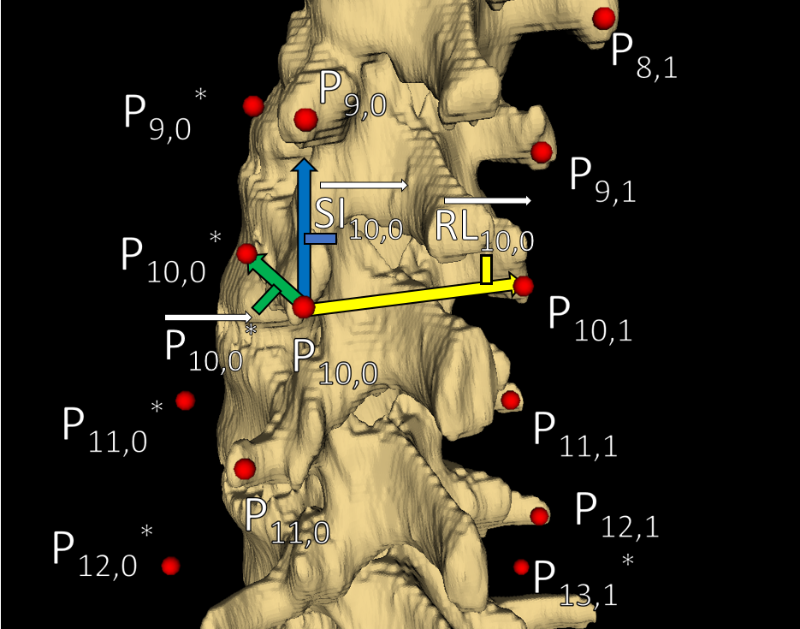

Figure 2: A segment of patient #1’s CT-derived spine model with transverse process points, added anchor points, and illustrations of the vectors used to locate one of the anchor points. Right-sided anchor points are occluded by the   
model. Note that vectors are shown for illustration, and do not necessarily depict their direction or scale exactly.

Our registration was implemented as a thin-plate spline transformation between the two sets of points   
[Bookstein 1989]. Details of the implementation are available open-source in the Visualization Toolkit ([www.vtk.org](http://www.vtk.org)). The thin-plate spline implementation meant that transformations, which mapped each transverse processes and anchor point of the average model to its corresponding point in the patient’s set, were smoothly interpolated. This allowed the entire surface of the average spine model to be deformed onto the patient’s points.

# RESULTS

Quantitative evaluation of the models produced by registration was performed by calculating typical volume similarity parameters: the average Hausdorff distance, the maximum Hausdorff distance, and the Dice similarity coefficient. These metrics are shown for each modelled patient in Table 1.

|  |  |  |  |  |
| --- | --- | --- | --- | --- |
|  | | **Registration Metric** | | |
| **Average Hausdorff Distance (mm)** | **Maximum Hausdorff Distance (mm)** | **Dice Similarity Coefficient** |
| **Patient #** | **1** | 2.1 | 13.2 | 0.695 |
| **2** | 2.9 | 28.7 | 0.673 |
| **3** | 2.3 | 18.8 | 0.682 |
| **4** | 2.5 | 19.1 | 0.643 |

Table 1: Registration evaluation metrics

The use of quantitative metrics to evaluate the accuracy of a registration method designed to produce models for qualitative assessment of spinal deformation is potentially misleading. Such quantitative metrics might best be used to assist in developing new methods by comparison. To demonstrate the qualitative accuracy of the registration results, Figure 3 shows the average spine model deformed to patient #1’s transverse processes (and anchor points), the   
CT-derived surface model of patient #1’s scoliotic spine with the ribs manually trimmed as a ground truth, and a heat map over the surface of the deformed average spine model, showing the distance between the registration and ground truth models.

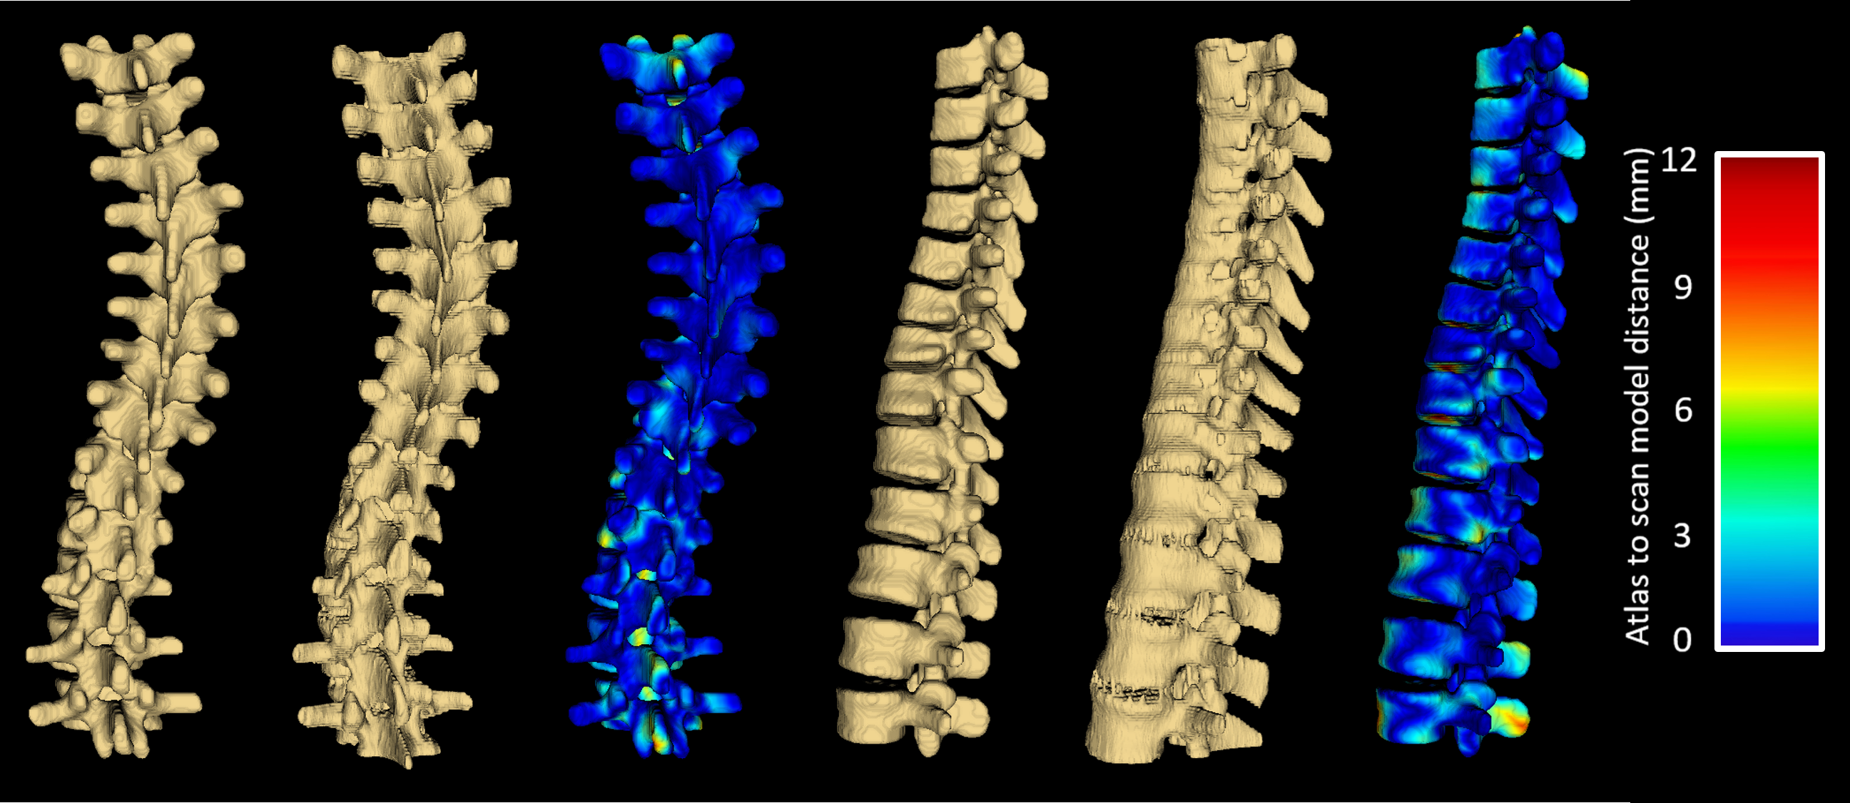

Figure 3: The left trio of models are: the average model deformed to patient #1’s transverse processes (and anchor points), patient #1’s CT-derived spine model depicting a ground truth, and a heat map showing the distance between those two models, viewed from the posterior direction. The second trio are the same models viewed from the left direction.

# CONCLUSIONS

The landmark based model registration method presented in this paper is capable of producing models displaying the 3D deformation of patients’ spines using just two ultrasound-accessible landmarks per vertebra as input. Most of the misalignment between the models is in the vertebral bodies, where no landmarks were placed. Misalignment in the vertebral bodies is of secondary importance to the vertebra’s posterior faces, since most features of clinical interest are on these posterior faces.

# REFERENCES

Berton, F., Cheriet, F., Miron, M., and Laporte, C., “Segmentation of the spinous process and its acoustic shadow in vertebral ultrasound images,” Computers in Biology and Medicine 72, 201-211 (2016).

Bookstein, F., “Principal Warps: Thin-Plate Splines and the Decomposition of Deformations,” IEEE Transactions on Pattern Analysis and Machine Intelligence 11, 567-585 (1989).

Frerich, J., Hertzler, K., Knott, P., and Mardjetko, S., “Comparison of Radiographic and Surface Topography Measurements in Adolescents with Idiopathic Scoliosis,” The Open Orthopaedics Journal 16, 261-265 (2012).

Gill, S., Abolmaesumi, P., Fichtinger, G., Boisvert, J., Pichora, D., Borshneck, D., and Mousavi, P., “Biomechanically constrained groupwise ultrasound to CT registration of the lumbar spine,” Medical Image Analysis 16, 662-674 (2012).

Ungi, T., Moult, E., Schwab, J.H., and Fichtinger, G., “Tracked ultrasound snapshots in percutaneous pedicle screw placement navigation: a feasibility study,” Clin Orthop Relat Res. 417(12), 4047-4055 (2013).